CHINA  INTERCOUNTRY ADOPTION PROGRAMME |  | 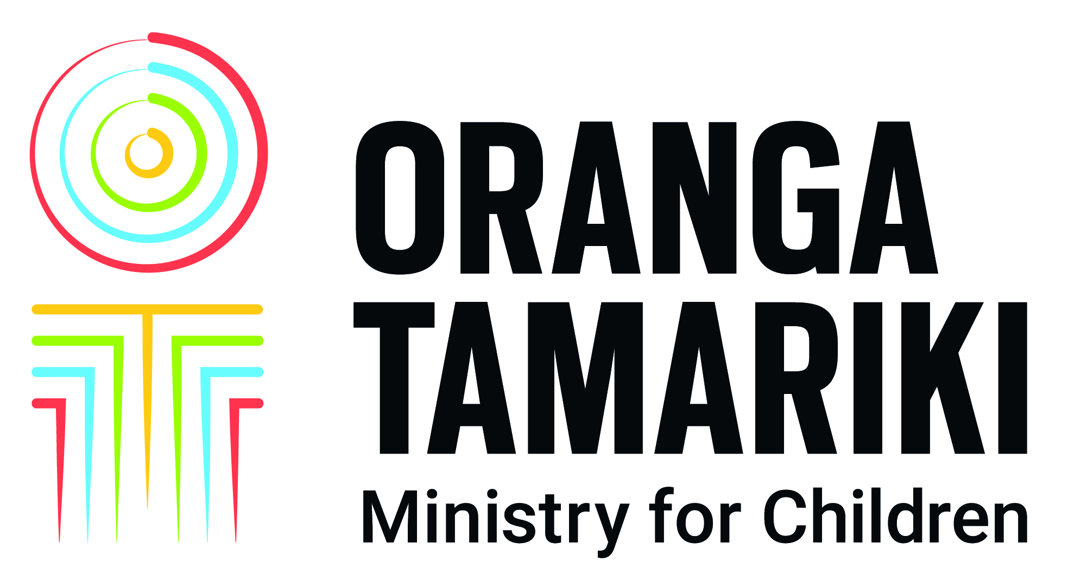
Last Updated: July 2019
Programme | Central Authority: The Ministry of Civil Affairs of the People's  Republic of China authorises the China Centre for Children’s Welfare and Adoption (CCCWA) to facilitate its practical functions. http://cccwaen.mca.gov.cn/
Legislation | An intercountry adoption of a Chinese citizen is finalised administratively in China. The required documentation is provided by the Chinese Civil Affairs in the Provincial Capital City where the adoption takes place.
Hague Convention | The Republic of China has ratified the Hague Convention and it entered into force in 2006. As both China and New Zealand have agreed to follow this Convention, the adoption must comply with the Hague Convention principles and processes.
Facilitation | The New Zealand Central Authority (NZCA) utilises the Beijing Jade Rainbow International Travel Service (BJRITS) to act as an escort/travel service for adoptive applicants.
Applicant Criteria | The CCCWA has very detailed specific criteria that applicants must fulfil to be accepted in China as prospective intercountry adoptive parents – detailed below.
Applicant couples | Applications are accepted from married couples whose relationship is stable. The marriage must be of at least 2 years duration, unless it is the second marriage for either of the applicants. In this case the marriage must be of at least 5 years duration. Neither of the applicants may have been married more than twice.  The CCCWA will not accept couples in a de-facto or same sex relationship.
Single Applicants | Single women can adopt. CCCWA does not accept applications from single men. CCCWA state that single women applicants must have “no homosexual tendency” and must make a statutory declaration to this effect.
Citizenship | The applicants must be a New Zealand Citizen or hold New Zealand Permanent Residency status. The applicants must be habitually resident in New Zealand.
Health | The CCCWA has a list of detailed health screening criteria including exclusion criteria relating to obesity, medication, mental health and medical and/or surgical history.
Age of Applicants | The applicants must have reached 30 years of age. There is no identified upper age limit for applicants, however:  - When a couple adopts together and the age of the younger party is older than 50, the age difference between the younger party and the adoptee should be no more than 50 years.  The age difference between a single adoptive mother and the adoptee should be no more than 45 years.
Education | Both the husband and wife must have received education to a New Zealand Year 12 Level (previously known as 5th Form), or has received vocational skills training; eg: completed an apprenticeship.
Character | Both applicants should be of good moral character. An adoption application will be given consideration on a case-by-case basis when either of the applicants has:  i) less than three criminal records of slight severity with no  severe outcomes that occurred at least 10 years  prior to the application; or  ii) less than five traffic law violations with no severe outcomes.  A history of the following shall preclude consideration of any application:  i) domestic violence, sex abuse, abandonment or  abuse of children (even if an arrest or criminal  proceedings did not eventuate);  ii) taking drugs including opium, morphine, marijuana, cocaine, heroin and/or methamphetamine, etc;  iii) alcohol abuse, unless the applicant has abstained for 10 or more years.
Existing Children in Family | Infertility is not a criterion and the CCCWA will accept families who have existing biological children or who have adopted children from other countries.  Adoptive applicants are required to have enough time and energy to take care of the minors in the family including the prospective adoptee. CCCWA indicate that it is their preference to place children in a family in order. For single applicants there cannot be more than three children under the age of 18, and the youngest child must be at least 6 years old.
Finance | At least one party of a couple must hold a stable occupation and an acceptable level of income.  The net family assets should be a at least $US80,000.00 (for a couple) or $US100,000.00 (single applicant).  Any welfare income, like a Government benefit or pension, cannot be counted as contributing to the family annual income.
Children available for intercountry adoption | Children available for intercountry adoption are state wards in care in Social Welfare Institutions in China. They are Chinese, and can be aged from under 12 months to 3+ years at time of placement, depending on the age of the applicants.  It is unusual for siblings to be available.
Waiting time between receipt of documentation in the China to a child being matched | Changes in the Chinese economy and the relaxation of the “one child policy” means that the need for intercountry adoption for Chinese children has reduced dramatically. Currently the wait for a match from the CCCWA is over 12 or more years. Applications from applicants who match the criteria regarding Chinese descent may be expedited; however this only reduces the wait-time by approximately 12 months.
Time between acceptance of a child and travel | Approximately two months.
Travel requirements | Both applicants are required to travel. The length of stay in China to process the adoption proposal is approximately 13 to 15 days. The applicants are escorted by the BJRITS. Interpreters and escorts are provided as part of the BJRITS service.
Child’s background information | The following information is provided:  - background to coming into care,  - medical interventions since in State care,  - a detailed developmental assessment provided for each child.  As most are abandoned, few children have any identifying information about their birth family.
Approximate costs | - Adoption service fee of $US1,100.00  - Translation costs  - Accommodation / travel to and from China  - There may be costs associated with travel within China  - Costs for BJRITS fees – approximately $US5,750.00  - Chinese adoption fees (approximately 41,000.00 (Chinese Yuan Renminbi)  - Costs incurred while in China (eg food)  Post placement report translation fees ($US60.00)
Post Placement report | Following the placement, reports need to be submitted to the CCCWA at the following intervals from the date of adoption;  - Six months (written by Social Worker)  - 12 months (written by Social Worker)  - Two years (written by Social Worker)  - Three years (written by the adoptive family)  - Four years (written by the adoptive family)  - Five years (written by the adoptive family)  Additional reports may be required in some circumstances
This fact sheet provides a brief general overview of the China Centre for Children’s Welfare and Adoption requirements and process. Intercountry adoption criteria, processes, costs, and children in need of intercountry adoption, change frequently. Applicants should speak to a social worker to confirm the most up to date information.
Oranga Tamariki – Ministry for Children, July 2019

