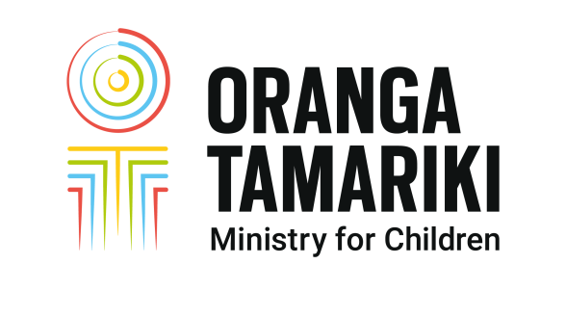



**Pre-family group conference planning meeting**

**Date:**

|  |  |
| --- | --- |
| **Tamariki details** (see referral for full information) | |
| Name |  |
| Age |  |
| Ethnicity |  |

|  |  |
| --- | --- |
| **Staff present** | **Name** |
| Co-ordinator |  |
| Supervisor |  |
| Social worker |  |
|  |  |
|  |  |

|  |  |
| --- | --- |
| Assessments required for the family group conference |  |
| Tamariki voices: How will they participate before, during and after |  |
| Cultural considerations: What supports/resources are required to convene and hold a family group conference that demonstrates respect and understanding of cultural needs |  |
| Whānau exploration: What has been done/ what needs to be done further |  |
| Safety issues for tamariki, whānau, professionals and Oranga Tamariki staff |  |
| Whānau dynamics including family violence |  |
| Barriers to attendance: Geographical; bail conditions; emotional and physical safety concerns including personal safety orders i.e. protection orders, restraining orders etc. |  |
| Roles and responsibilities of Oranga Tamariki staff |  |
| Services, resources and funding options |  |
| Possible delays in holding the family group conference?  Is the current plan robust enough until the conference is held? |  |



# 